Senate Committee on Indian Affairs
Oversight Hearing on Irrigation Projects in Indian Country
September 10, 2014
2:30 p.m.

Testimony of Chairman Darrin Old Coyote
Crow Nation

I. Introduction

Good afternoon. My name is Darrin Old Coyote and I am the Chairman of the Crow Nation. On behalf of the Crow Nation, I would like to thank Chairman Tester and members of the Senate Committee on Indian Affairs for holding this Oversight Hearing on Irrigation Projects in Indian Country and inviting the Tribe to provide testimony on our experience with the Crow Irrigation Project within the Crow Reservation.

As I will discuss in further detail below, the Crow Irrigation Project (“CIP”) has been the subject of considerable problems on the Crow Reservation for many decades. Historically, the CIP was operated and maintained by the Bureau of Indian Affairs (“BIA”), with a majority of the Operation and Maintenance (“O&M”) budget weighted towards personnel costs and deferred maintenance that resulted in extensive deficiencies with the CIP. Funding problems were compounded by a failure to collect assessments from users of the system, which left the system seriously underfunded. Thus, in an effort to remedy the vast failings of the CIP, the Crow Tribe Water Rights Settlement of 2010 was enacted to, among other things, rehabilitate and improve the CIP and provide meaningful Federal funding for such work. Today, we share our experience both in terms of the historic issues that have surrounded the CIP, as well as our current and future work with the Department of Interior through the Bureau of Reclamation as it has evolved since passage of the Crow Water Settlement legislation.
II. Brief Overview of Crow Irrigation Project

A. Brief History of Crow Irrigation Project

The CIP is located on the Crow Reservation in south-central Montana. The Crow Tribe’s first reservation, established in the Fort Laramie Treaty of 1851, was 35 million acres of land in Montana and Wyoming. In the Fort Laramie Treaty of 1868, the Crow Tribe agreed to reside on an 8-million acre reservation in south-central Montana and established the senior tribal water right claim of the Crow Tribe on May 7, 1868. Later land cessions from the Crow Tribe to the United States in 1882, 1891, and 1904 reduced the Reservation to its current 2.3 million acre size today. Importantly, each land cession and subsequent land sale by the United States to meet its treaty obligations to the Crow Tribe constituted the original and early subsequent appropriations for the Federal CIP.

In 1920, Congress passed the Crow Allotment Act, which triggered a massive land conversion from collective tribal to individual allotted Crow. The amount of land and the number of individual Crow allottees both doubled within fifteen years of this Act. However, for reasons outside of this testimony and despite a federal prohibition on the amount of acreage to ever be owned by a non-Indian individual (1,280 acres) or a corporation (1,920 acres), hundreds of thousands of acres ultimately passed to non-Indians within the Crow reservation. That historical fact, the legal issues, and claims associated with the lands subject to the 1920 Act remain in dispute to the present day. See 1920 Crow Allotment Act, Section 2, 41 Stat. 751 (1920); Crow Tribe v. Campbell Farming Corp., 31 F.3d 768 (9th Cir. 1994).

The first irrigation works, the Reno Ditch, was constructed by the Federal government in 1885. Surveys for the present CIP began in 1890. The first general authorization for the construction of the irrigation project on the Crow Reservation was contained in the agreement between the Crow Tribe and the United States, dated December 8, 1890, and ratified by Section 31 of the Indian Appropriation Act of March 3, 1891 (26 Stat. 989, I Kappler 407, 432). Designs, surveys, and construction for the CIP were performed by the United States Reclamation Service, now the Bureau of Reclamation (Reclamation), for the BIA until 1922. Reclamation constructed nine of the eleven units from 1885 to 1922. Further construction on the irrigation units was performed by the BIA after 1922. The remaining two irrigation units were privately constructed, with lateral ditches off of the main canals constructed by Reclamation in the early 1920s to serve Crow allotted lands. Active expansion of the irrigation units ceased in 1925 and nearly all of the irrigation facilities were completed before 1940.

Subsequent Congressional acts provided for continued construction and development on the CIP. The Act of July 1, 1932 repealed collection of construction costs against Indian owned lands under government irrigation projects until the land is no longer under Indian ownership. Public Law 79-468 (60 Stat. 333), Section 9 states, “[n]o further construction work on the Crow Indian Reservation shall be undertaken by the United States without the prior consent of: (1) the Crow Tribe; (2) the irrigation district or districts affected, and; (3) the Congress of the United States, and without the prior execution of repayment contracts by non-Indian water users or irrigation district or districts, obligating the non-Indian lands for the repayment for their share of such construction costs.” Public Law 79-468 further states, “that such consent shall not be necessary to construct laterals necessary to irrigate the lands within the CIP as now determined and classified as irrigable by the land designation committee report, as approved by the Secretary of the Interior in 1944.” The Public Law also cancelled all back debt to the United States government owed by all Indian owned land and also cancelled United States government debt to the Crow Tribe for funds expended from treaty settlements for the irrigation projects.

B. CIP Overview

The Crow Irrigation Project consists of eleven units with a total area of 63,365 acres. There are eleven diversion dams, one storage dam, nine canal systems and five drainage systems. Specifically, the eleven CIP irrigation units consist of the Bighorn, Agency, Forty Mile, Reno, Lodge Grass #1, Lodge Grass #2, Bozeman Trail, Upper Little Horn (Wyola), Pryor, Soap Creek, and Two Leggins Units. The Upper Little Horn Unit is also referred to as Wyola throughout as attributed to the fact that Wyola is the more common name used. Of these eleven units, the Bozeman Trail and Two Leggins Units are privately owned and operated, with the remaining nine CIP Units operated and maintained by the BIA’s office located in Crow Agency, Montana. The rehabilitation and betterment of the Bozeman Trail and Two Leggins Units will only occur where land is held in Trust by the United States for the Tribe and Crow Allottees are beneficiaries.

The CIP lands are located along the Bighorn and the Little Bighorn Rivers, Pryor Creek, Lost Creek, Sunday Creek, Soap Creek, and Lodge Grass Creek, all of which are tributaries to the Yellowstone River. The eleven units are located entirely in the Pryor, Lower Bighorn, and Little Bighorn Sub-basins, with the general direction of flow within both basins from southwest to northeast. Across the eleven units, the CIP consists of eleven diversion dams, one storage dam with a capacity of about 23,000 acre-feet, approximately 122 miles of main canals, 43 miles of drains, 257 miles of additional canals (e.g., laterals, sublaterals, and wasteways), and approximately 3,800 irrigation structures (including both BIA and non-BIA-owned structures) such as checks, drops, headworks, flumes, siphons, turnouts, road crossings, spillways, and diversion dams. All units are gravity fed and lack any automated flow measurement or gate controls, with the exception of the Bighorn Unit, which has automated gates controlled by Reclamation at the main diversion point (headworks) at the Afterbay below the Yellowtail Dam and Bighorn Reservoir.

In 2006, the CIP served approximately 1,118 water users. Current irrigation practices include both surface and sprinkler methods, with most irrigation methods consisting of flood, furrow, wheel-lines, gated pipe, and sprinklers with both unlined and lined ditches as distribution systems. Additionally, several select laterals and sublaterals have been converted to pipe, particularly in the Two Leggins Unit. The CIP serves both Tribal and non-Tribal landowners. Non-Tribal landowners in the two irrigation districts (Bighorn and Little Bighorn Districts) and private ditch companies (Bozeman and Two Leggins) in the CIP are organized as legal entities under Montana statutes. The Irrigation District Boards are chartered under state law and only represent owners of fee simple lands.

Most of the reservation is comprised of grasslands and plains with the Wolf Mountains to the east and Bighorn and Pryor Mountains to the southwest. The climate on the reservation varies from humid above 7,000 feet in the Bighorn Mountains, with 24 inches of annual precipitation, to semi-arid around 2,900 feet near Hardin, with 12 inches of annual precipitation. The primary source of water for the CIP originates on Tribal lands in the Bighorn Mountains. All CIP irrigation water is supplied by surface water sources. The primary irrigated crops are hay and alfalfa, irrigated pasture, sugar beets, corn, and grains. Precipitation averages 12 - 18 inches annually, with temperatures that vary from -48 to +110 degrees Fahrenheit, and the average growing season is 135 days from mid-May to the end of September.

Over the years, the Tribe asserted that the BIA’s role in overseeing and maintaining the CIP fell short of the United States’ trust obligation to the Tribe and Crow allottees to maintain the system. We saw that the vast majority of funds on the CIP were weighted towards personnel costs rather than much needed O&M. Most recently, for example, there has only been one BIA operator for the entire CIP system who performs such operations with 25 year-old equipment. Accordingly, the CIP continued to wear down and operate at a sub-optimal efficiency level. Indeed, the dilapidated conditions on the CIP spurred the Tribe’s efforts to ultimately settle the Tribe’s claims against the United States for failing to fulfill its trust obligations to the Tribe, and which resulted in the Crow Tribe Water Rights Settlement Act of 2010.

III. Crow Tribe Water Rights Settlement

The Montana Reserved Water Rights Compact Commission was established by the Montana legislature in 1979 for purposes of concluding compacts for the equitable division and apportionment of waters between the State and its peoples and the Indian Tribes claiming reserved water rights within the State. In 1999, the Montana State Legislature ratified the Crow Tribe-Montana Water Compact. MCA 85-20-901 (1999). By entering into this Compact, all interested parties settled their claims with the State of Montana and the Crow Tribe and avoided costly and lengthy litigation.

In 2010, the United States Congress passed the Crow Tribe Water Rights Settlement Act which further authorized, ratified and confirmed the Crow Tribe-Montana Water Rights Compact entered into by the Tribe and the State of Montana in 1999, and was signed into law by President Obama on December 8, 2010. Claims Resolution Act, P.L. 111-29, Tit. IV, 124 Stat. 3097 (“Crow Water Settlement”). One of the critical components of the Crow Water Settlement was Interior’s obligation to fulfill its trust obligation to properly maintain the CIP, which the Tribe asserted the United States had failed to do. The Crow Water Settlement specifically provided for Reclamation to carry out such activities as necessary to rehabilitate and improve the water diversion and delivery features of the CIP, in accordance with an agreement to be negotiated between the Secretary of Interior and the Crow Tribe. Crow Water Settlement, Sec. 405. In 2011, the Tribe and Reclamation entered into a Self-Determination Contract, commonly referred to as a 638 contract, to carry out the rehabilitation and improvement activities envisioned by the Crow Water Settlement.

Significantly, the Crow Water Settlement also authorized $132 million, adjusted to reflect changes since May 1, 2008, in construction cost indices applicable to the types of construction involved in the rehabilitation and improvement of the CIP. Of that authorized amount, $73, 843,000 was a mandatory appropriation, with the remaining $58,000,000 as authorized discretionary funds. Crow Water Settlement, Sec. 414(a). We cannot emphasize enough the importance of the mandatory funding that was included in our Settlement, which was a direct result of Chairman Tester and former Senator Baucus’ diligent efforts to find funding offsets. As you are keenly aware, the mandatory appropriations provide direct funding to enable the Tribe to begin work immediately on the CIP. That being said, it has been emphasized that the discretionary portion of the BIA irrigation funding, approximately $8 million per year, will need to be substantially increased in the upcoming fiscal years to avoid layoffs and cyclical employment.

Notwithstanding the anticipated increase in construction costs as the project progresses, the mandatory funding element of the Settlement is critical towards the overall intent and success of the Settlement. Thus, while we recognize that identifying offsets and providing for mandatory funding in Indian Water Settlements is a difficult task to say the least, we highly recommend that future Indian water settlements strive to include mandatory funding. We also urge Congress not to forget that the mandatory funding for our and other Indian water settlements will run out and we will need Congress to be prepared to appropriate the funds necessary to complete the critical work of our settlement, including our work on the CIP.

Lastly, with respect to the Crow Water Settlement legislation itself, we were able to include a provision within the Settlement that allowed for flexibility between our two large construction projects—the CIP and the MR&I System (clean drinking water system). Section 414(h) provides that the Secretary of Interior may transfer funds between the CIP account and the MR&I account as the Secretary, with the concurrence of the Tribe, determines to be necessary. We have already noticed the benefits of carving this type of flexibility into the legislation, which in our case was especially important as we work to rehabilitate the existing CIP system and construct a new MR&I System within the Crow Reservation. Again, we would recommend that future Indian water settlements consider such provisions in their settlements if they envision needing a certain level of flexibility between their relevant construction activities.

IV. Current and Future Outlook for the CIP

The Crow Water Settlement provides much needed funding and directives to Reclamation to carry out the necessary construction to improve the overall efficiency of the CIP. Unlike the historical management of the CIP by the BIA, the Crow Water Settlement provided that Reclamation would serve as the lead agency on the project going forward. While the Tribe certainly supported Reclamation serving as the lead on the CIP moving forward, we have experienced early obstacles (perhaps due to an expected learning curve by Reclamation with Indian irrigation projects as opposed to their standard non-Indian projects), both in terms of the level and balance of BOR oversight on the project, as detailed below.

Once construction and improvement continues we expect that project-wide efficiency of the irrigation system to the farm turnouts will be roughly 30 percent. Moreover, future irrigation water demands should decrease from the current existing irrigation system demands with improved system efficiency resulting from rehabilitation and betterment efforts. Efficiencies of 50-70% could potentially be realized through a combination of CIP rehabilitation and betterment efforts and improved system O&M. CIP rehabilitation and betterment, in conjunction with improved O&M, may also help to increase irrigation wastewater quality by decreasing pollutant concentrations within the system (e.g., sediments, chemicals, etc.). Reductions in water pollutant concentrations in wastewater ultimately, however, will be largely dependent on individual on-farm irrigation methods and practices.

The total irrigated acres may increase if additional acres currently in TNA (Temporarily Non-Assessed Acres, which are currently not receiving water for various reasons) status can be brought into PA (Presently Assessed acres) status. Currently 8,200 acres of land are identified as TNA. Some of these tracts of land have potential to be irrigated and assessed with minor rehabilitation. The addition of on-farm improvements in other areas may also add more irrigated land, as would the development of additional lands for irrigation (Dunmore Bench).

A. CIP 638 Contract

As discussed above, the Crow Tribe entered into a 638 Contract with Reclamation to implement the CIP. In the first two years of the Settlement Act implementation, we experienced inconsistent oversight, both from the Tribe’s perspective and Reclamation’s perspective (as referenced above), that resulted in minimal funding to the Tribe from March 2013 to January 2014 and that caused construction crew layoffs for the entire irrigation season. In contrast, FY2012 seemed to have very little oversight from Reclamation, and then an abrupt change occurred that resulted in significant Reclamation oversight – thus crippling the project’s movement. Fortunately, after difficult discussions and negotiations, we have evolved to today’s level of oversight that is a happy median, which we believe will lead to successful interactions with Reclamation in the future.

Additionally, the Tribe encountered another substantial obstacle during this first phase of implementation under the 638 Contract when Reclamation demanded that the Tribe advance the funds for construction from the Tribe’s general government operating fund (approximately $20 million per year) and be reimbursed after each Reclamation audit. As would undoubtedly be the case for many tribal budgets, this became impossible for the Tribe (it would have caused other tribal department shutdowns and layoffs to provide the advance funding for the water projects). We voiced these concerns with Reclamation and ultimately worked out a mechanism in which the Tribe will no longer have to advance the funds from the Tribe’s general fund. Hence, this year’s 2015 Annual Funding Agreement (“AFA”) appears to be on track and we are optimistic that the following important milestones will be achieved.

- Crow Irrigation Project Master Plan
The 638 Contract executed by the Tribe and Reclamation in 2011 included a requirement that the parties draft a CIP Master Plan of project construction activities and responsibilities under the Contract. The Final Draft CIP Master Plan was reviewed by Reclamation and the BIA, with all final comments received on August 29, 2014. The Final CIP Master Plan was submitted to Reclamation last week for final review and acceptance.

It is anticipated that Reclamation will provide a formal response to the Final CIP Master Plan in the form of a letter, and provided that no additional comments warranting revision in the Master Plan are supplied, the Final CIP Master Plan will then be provided for final signature by the Crow Tribe’s Chairman, Crow Tribal Water Rights Office Director, and Engineer of Record (Bartlett & West). The Master Plan is important as an overarching document with generalized approval of projects over the duration of the settlement with expected oversight of project specifications, funding adjustments, and other issues as they arise.

- CIP Environmental Assessment
The CIP Environmental Assessment (EA) is also nearing completion. The CIP EA has been reviewed internally be Reclamation, and is scheduled to be distributed for a one month public comment period by September 15, 2014. Following the public comment period, a response to all comments will be prepared, and all EA documents are expected to be finalized. The issuance of a signed FONSI by Reclamation is anticipated by the end of 2014.

B. CIP Completed and Future Work

Construction work on the Crow Irrigation Project under the Settlement Act commenced in 2012, and has continued since that time but in a somewhat reduced scope of activities. Construction work on projects during this timeframe has been primarily limited to smaller rehabilitation projects, and is contingent upon final sign off on the CIP Master Plan to proceed forward at full scale construction. A number of large rehabilitation projects are scheduled to commence construction in calendar year 2015, and include major structures on the Bighorn and Forty Mile Units, as well as the Willow Creek Feeder Canal (Lodge Grass Feeder Canal).

Another significant issue that we have encountered (after engaging in more specific project reviews and implementation) is that the current condition of the irrigation structures and redesign options from original cost estimates by engineering consultants have increased in many cases (e.g., originally undersized bridges, culverts, etc.). This fact poses new challenges for the Tribe and Reclamation to fulfill the objectives of the CIP while staying within the $132 million budget. We recognize that this ultimately means that the Tribe will need to search for more creative solutions to resolve underlying unanticipated and major estimated design system flaws (based primarily on poor oversight and enforcement of the system by the BIA in the past).

One of the benefits of funding the rehabilitation and improvement of irrigation systems on Indian Reservations is that the results are tangible. You can see a tangible difference that Federal dollars make on the ground in the day-to-day functionality of the systems in Indian country. As such, we have provided a few examples below of what the CIP looked like before and after the Crow Water Settlement implantation began to demonstrate how the appropriated funds have made a difference on the Crow Reservation to rehabilitate and improve much needed segments of the CIP.

1. 2012 Completed Projects

a. Agency Diversion

The Agency Diversion Riprap Repair project was completed by the Crow Tribe Water Rights Department (“CTWRD”) during the fall of 2012 and spring of 2013. Work completed under this project generally consisted of:

- Placing compacted soil to fill the eroded bank area on the east side of the Little Big Horn River.
- Placing geotextile fabric and rock to armor bank area.
- Site grading, surface restoration and seeding.

b. Lodge Grass No. 1

The Lodge Grass Canal No. 1 Headworks rehabilitation project was completed by the CTWRD during the winter of 2012 and 2013. Work completed under this project generally consisted of:

- Construction of cofferdams and dewatering in Lodge Grass Creek.
- Demolition of a portion of the old deteriorated headwall.
- Construction of a concrete overlay over the deteriorated headwall.
- Construction of two new concrete walkway support walls.
- Installation of a new steel walkway over Lodge Grass Creek.
- Site grading, surface restoration and seeding.

Before: After:
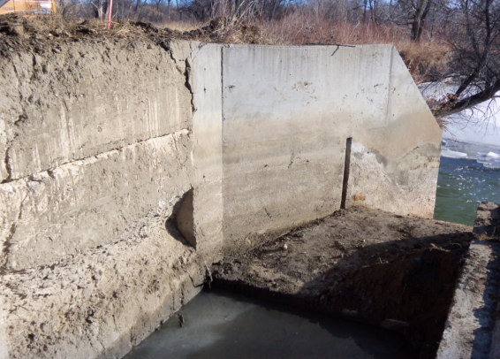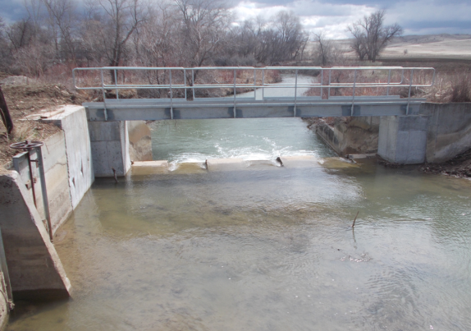

c. Lodge Grass No. 2

The Lodge Grass Canal No. 2 Headworks rehabilitation project was completed by the CTWRD during the winter of 2012 and 2013. Work completed under this project generally consisted of:

- Construction of cofferdams and dewatering in Lodge Grass Creek.
- Demolition of a portion of the old headworks structure.
- Construction of new headwork structures including cast-in-place concrete walls and slab and installation of precast concrete box culverts and three slide gates.
- Construction of two new concrete walkway support walls.
- Installation of a new steel walkway over Lodge Grass Creek.
- Site grading, surface restoration and seeding.

Before: After:
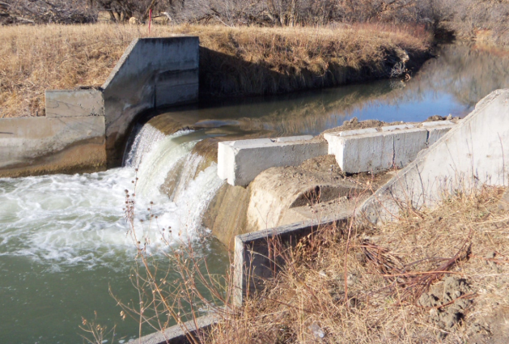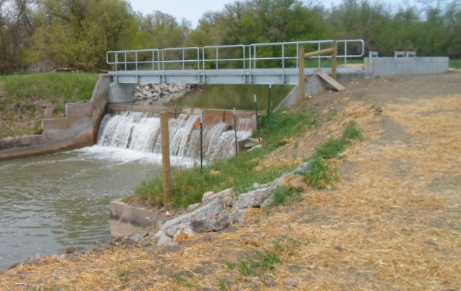

2. 2013 Completed Projects

a. Bighorn High Check Emergency Repair

Emergency repairs were completed in the spring of 2013 to stabilize the structure and to prevent its failure until it could be fully rehabilitated in FY2015. Work consisted of the following:

- Backfill was imported to fill in the erosion
- Extended downstream concrete apron
- Install EPDM liner with riprap ballast to reduce further erosion

Before: After:

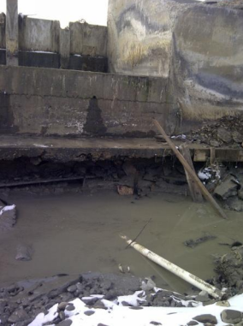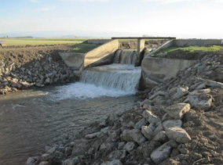

b. Reno O&M Road Improvements

It was determined that O&M road improvements were necessary from the Old Hwy 87 Frontage Road to the Reno Diversion Dam and Headworks. The improved road will provide all weather access to the Reno Diversion Dam and Headworks and Siphon. It will also help facilitate construction when the Reno Diversion Dam and Headworks and the Siphon are rehabilitated and for future O&M activities on the structures thereafter. The Reno Diversion Dam and Headworks is planned for rehabilitation in FY2015. The Reno Siphon is planned for replacement in FY2015.

Before: After: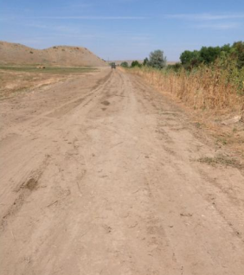 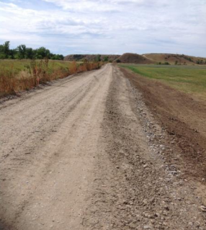

c. Rotten Grass Wasteway

It was determined that stabilization and erosion protection improvements were necessary for the Rotten Grass Wasteway. Immediate efforts were needed to protect the structure and downstream channel from further erosion and damage, and allow for continued operation of the wasteway.

Before: After:
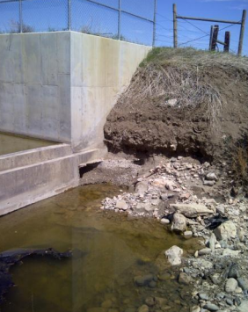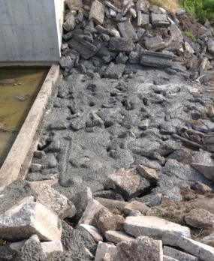

3. 2014 Completed Projects

a. High Check O&M Road Improvements

It was determined that O&M road improvements were necessary from the Little Owl Loop Road to the vicinity of High Check. The improved road would provide all weather access to High Check and the turnout for Lateral 728. It would also facilitate construction when High Check and High Drop are replaced and for future O&M activities on the structures thereafter.

Before: After:
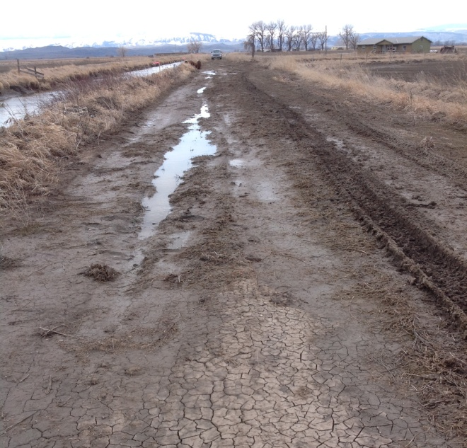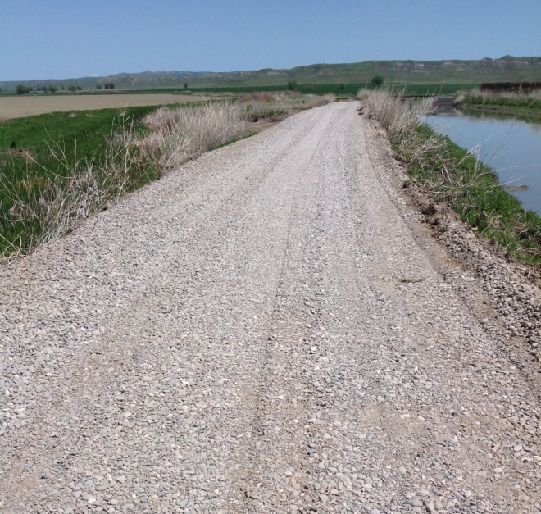

4. Major Upcoming Construction Projects

There are a number of projects that are planned for 2015.

a. Willow Creek Feeder Canal Phase I, II, & III

- Install riprap below the diversion dam and headworks structures and install new slide gates on the headworks.
- Replace the existing stop logs in the wasteway with a slide gate and restore the radial gate to operation.
- Remove brush and trees and reshape the canal prism.
- Install earthen lining for select reaches of the canal to address seepage concerns.
- Construction of a new terminal drop structure.

b. Reno Diversion Dam, Headworks, and Flume

- Install one Obermeyer gate and construct a radial gate sluiceway.
- Remove and construct a new headwork structure.
- Remove and replace existing ramp flume.

c. Forty Mile Headworks & O&M Road

- Remove the existing headworks and construct a new structure with a new slide gate.
- Remove the existing Parshall flume and constructing a new Parshall flume.
- Stabilize river bank adjacent to the new structure.
- Complete improvements to the existing O&M road including leveling, grading, and placing gravel.

d. Bighorn High Check

- Removing old structure and replacing with a new check structure.

V. Conclusion

Every Indian irrigation system is unique and poses its own challenges. In our case, we are dealing with several decades of deferred maintenance on the CIP that must be remedied on a strategic and forward-thinking approach in order to make the most out of the Crow Water Settlement funds. As we make progress, we will also have to ensure that the future funds for operation, maintenance and replacement are collected from users on a timely basis or we will face the same funding shortfalls that plagued the system in the past. Even though we have experienced a few temporary setbacks in the implementation of the Settlement, we are headed in the right direction and are optimistic that the CIP will ultimately be restored to the state it was originally intended to be for the Crow Indian Reservation.

